

Data Technician

Name:
Course Date:
Table of contents
Day 1: Task 1 2
Day 1: Task 2 2
Day 2: Task 1 4
Day 2: Task 2 5
Day 3: Task 1 10
Day 3: Task 2 12
Day 4: Task 1 13
Day 4: Task 2 15
Course Notes 16
Additional Information 17

Day 1: Task 1

Please research the different versions of Tableau, compare and contrast them below and explain the limited functionality on ‘Tableau Public’.

Different Tableau versions | Tableau Public is a free version with restricted connectivity to file-based data sources and required public publication. In contrast to commercial versions like Tableau Desktop and Tableau Server/Online, which include more connections, private data storage, automation, and security.

Day 1: Task 2

Using the EMSI_JobChange_UK dataset, create your own dashboard, I want to see a bar chart showing percentage change and a UK based map showing the key city locations impacted.

Paste your print screen here | 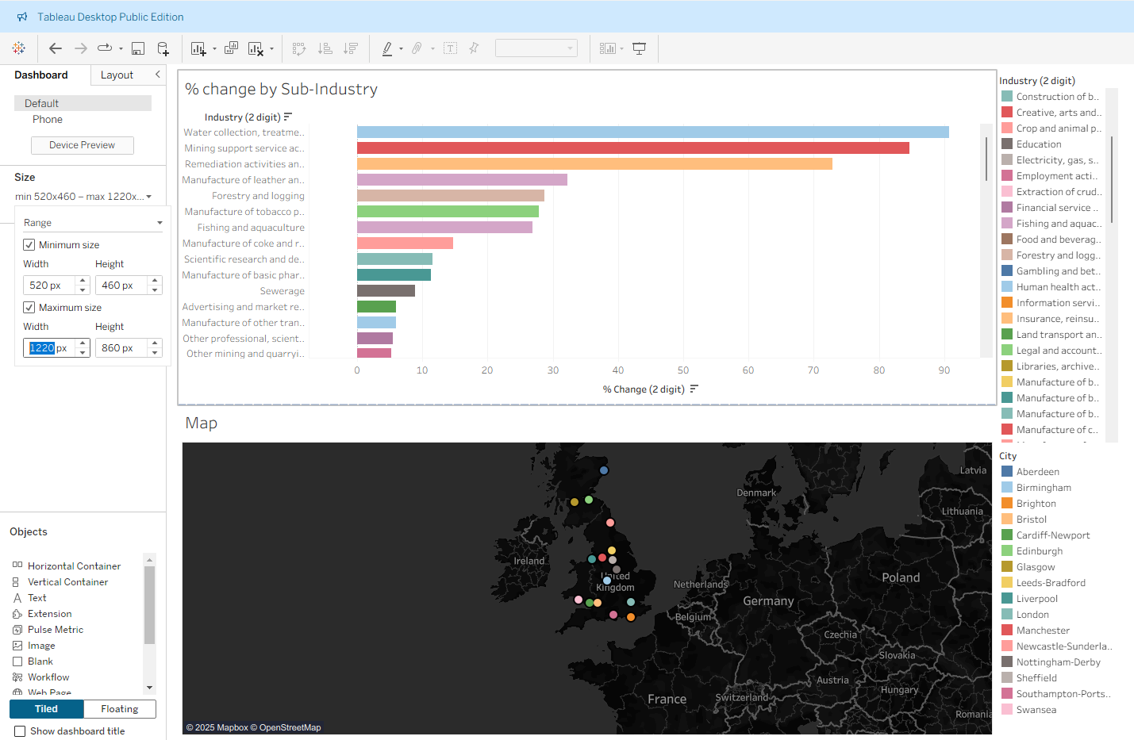

Day 2: Task 1

Using the Spotify data set, conduct an analysis to find trends and key information that could be used by an organisation for future projects.

There is no set scope for the analysis, simply to find trends and document them below:

Paste your print screens here | 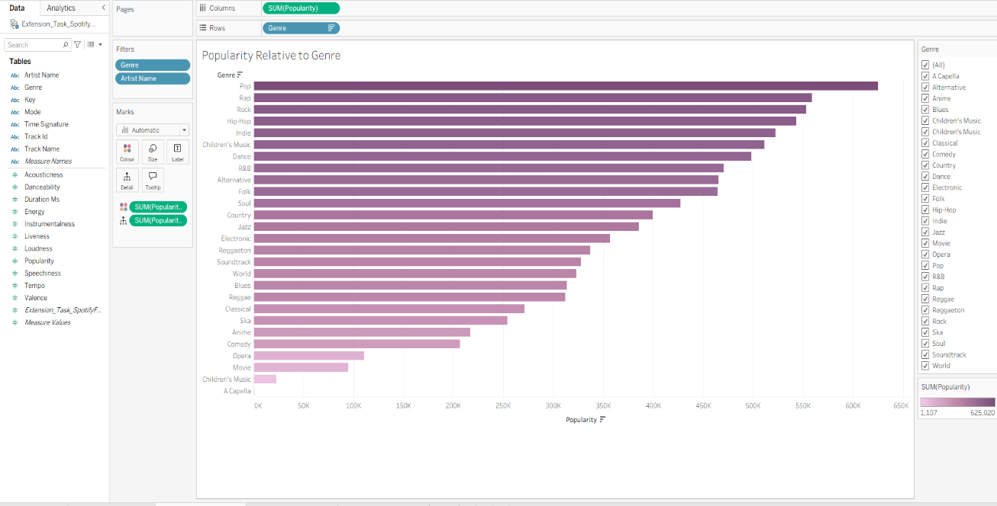  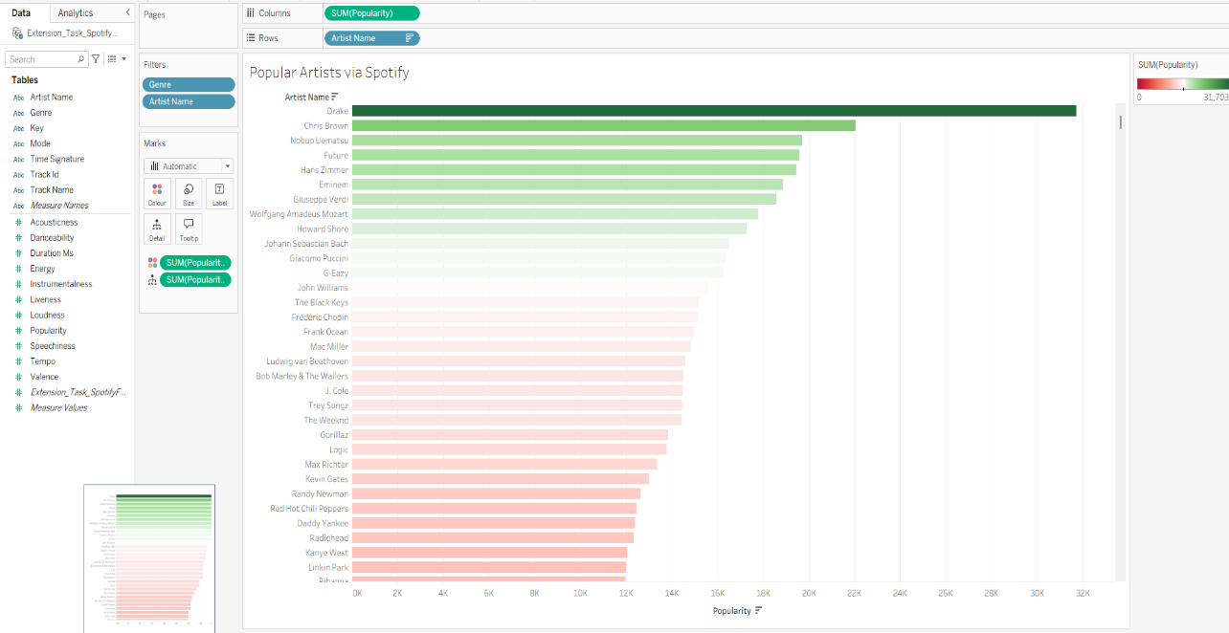  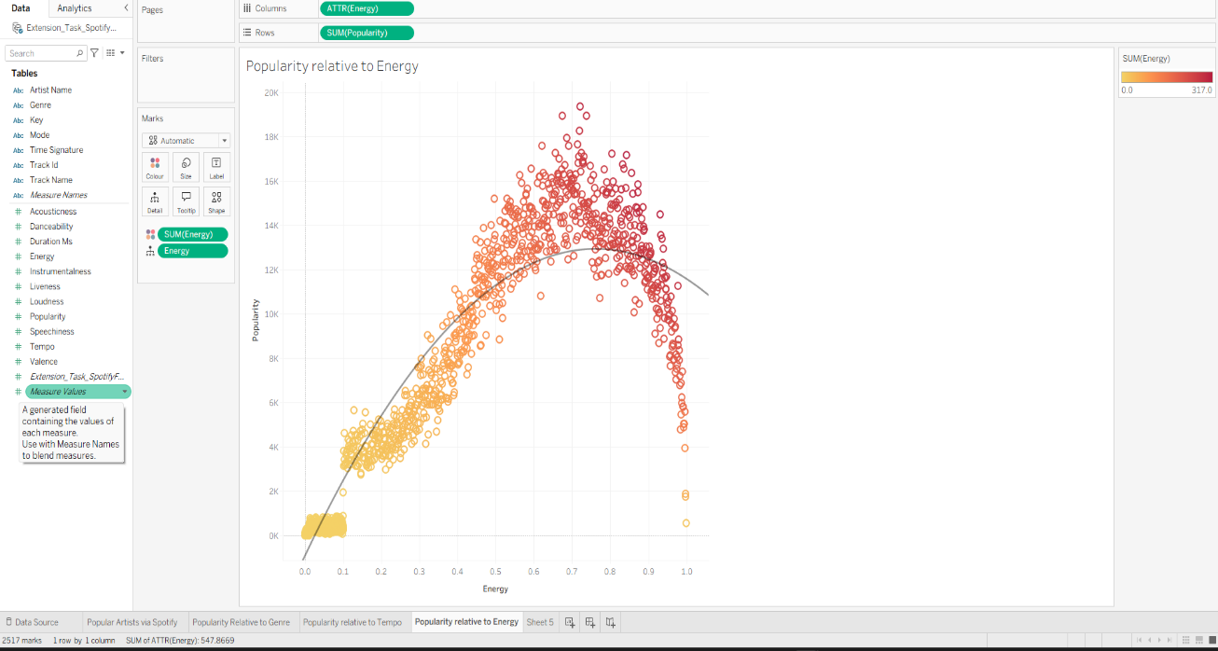  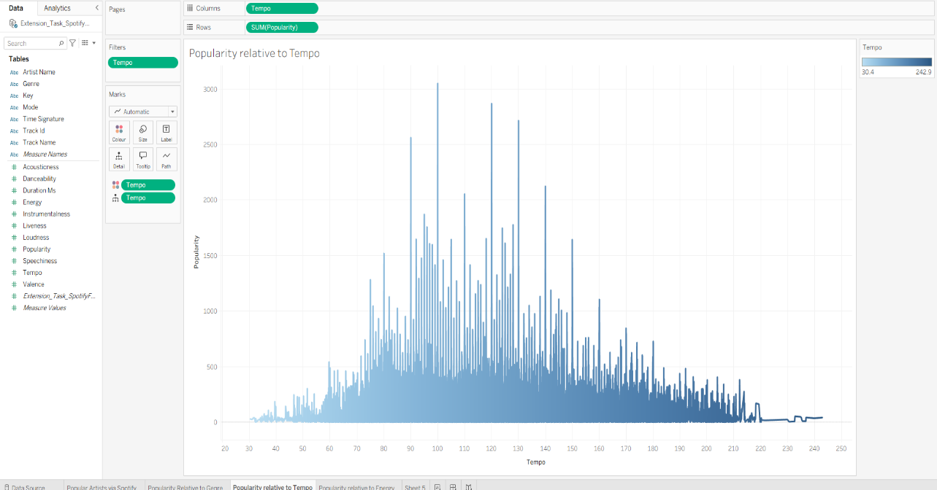  Before conducting this analysis, the initial question was “does the popularity of music increase proportionally with an increase in tempo and also energy?” What I found with this task was that popularity relative to tempo had large spikes in the 90-130 bpm range and popularity relative to energy the highest values of popularity were in the 0.6-0.81 range. These ranges are in the latter half of the mid-range values, where the highest value for tempo was 242.9bpm with a popularity value of 42 and the highest energy value was 0.99 with a popularity value of 545. In conclusion the answer to my initial question would be no given the data that has been provided.

Day 2: Task 2

Using the Health data set, conduct an analysis to find trends and key information that could be used by an organisation for future support.

What did you find? | 1. Health Outcome Trends  Track Life Expectancy changes by continent and country.  Highlight countries with stagnant or declining improvements.  2. Chronic Disease Risk Alerts  Identify regions with high Blood Pressure, Cholesterol, BMI.  Correlate these with Cancer incidence for early intervention planning.  3. Gender-Based Health Disparities  Compare Life Expectancy and BMI by gender to identify inequality.  4. Population Growth vs Health Pressure  High Population Growth + Poor Health Metrics → potential hotspots needing increased support.  5. Top Priority Countries  Using a multi-factor score: (Low Life Expectancy + High Risk Indicators + High Growth).

There is no set scope for the analysis, simply to find trends and document them below.

- Data can be lifesaving and is being used more within the NHS, reflect on how this data could support decision making for the NHS.

Paste your print screens here | 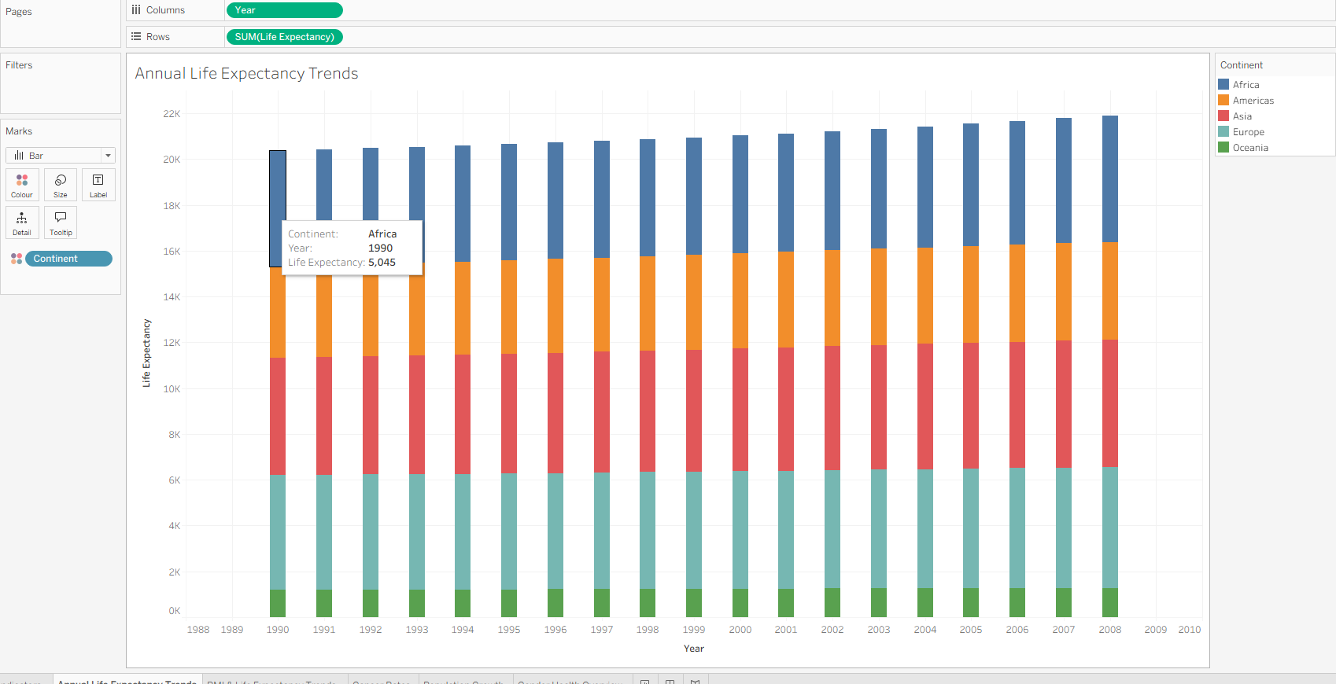  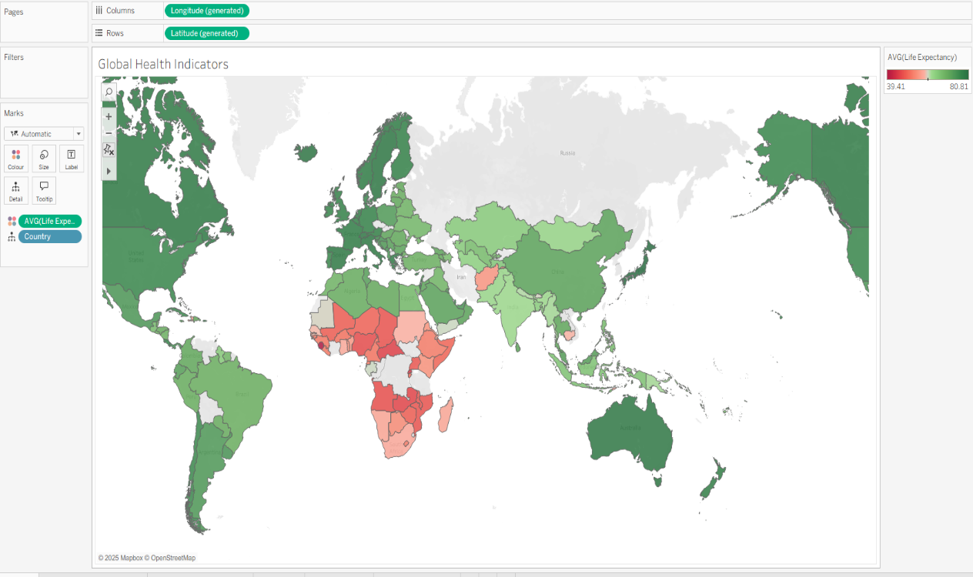  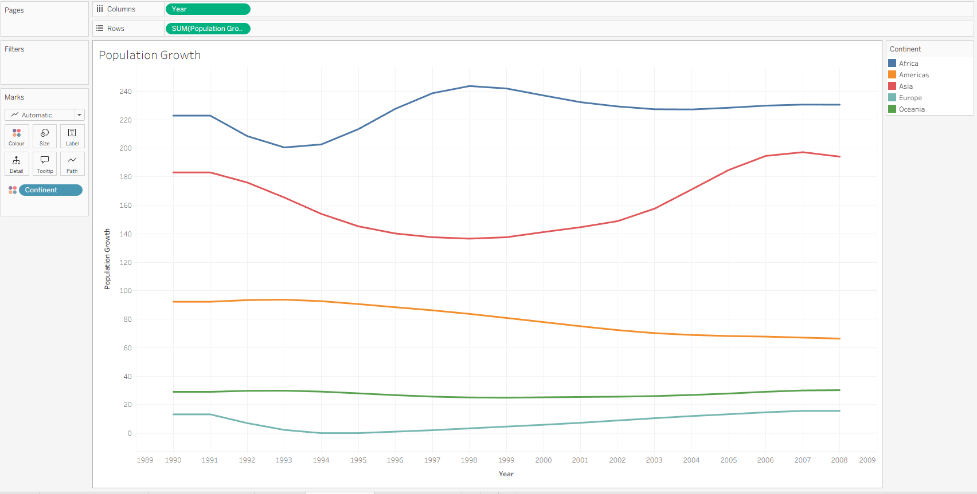  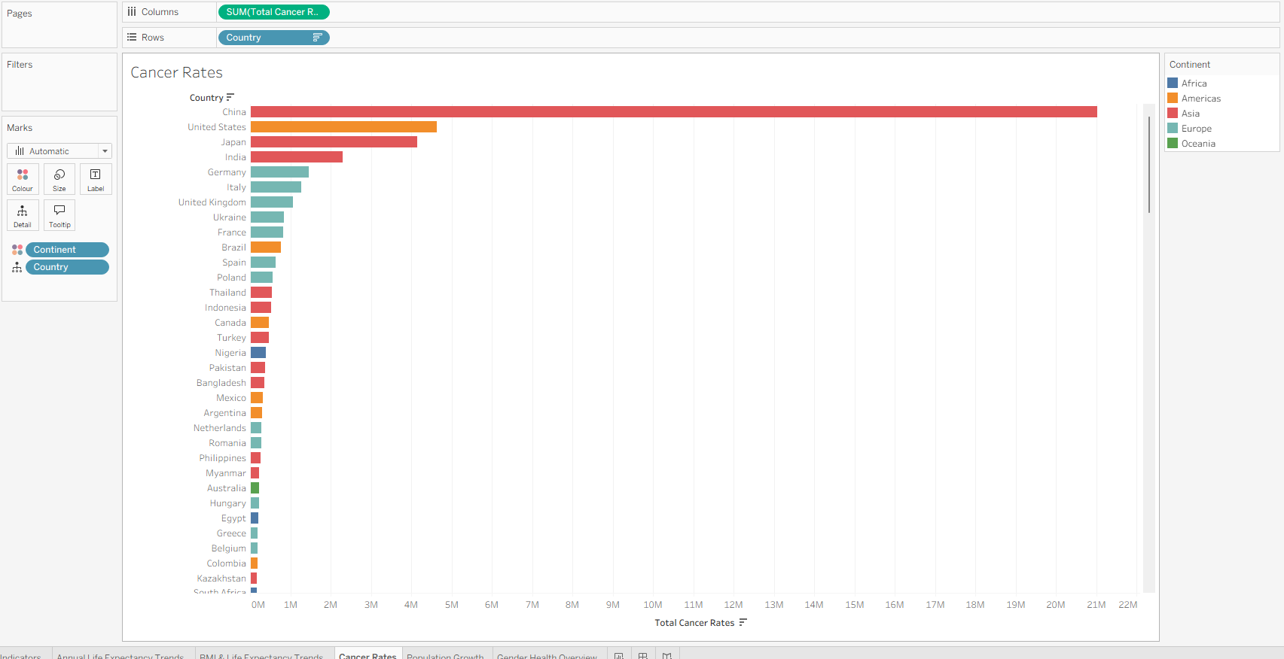  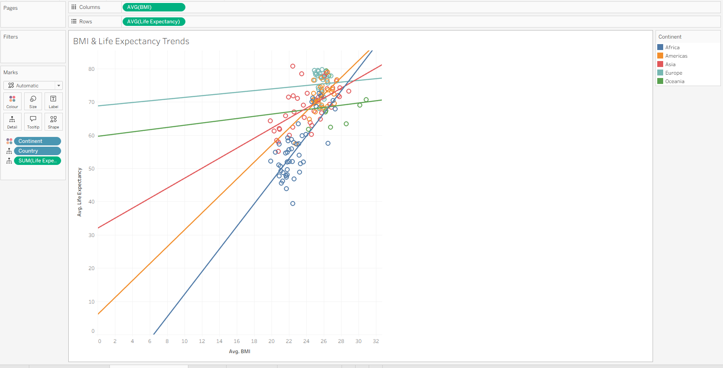  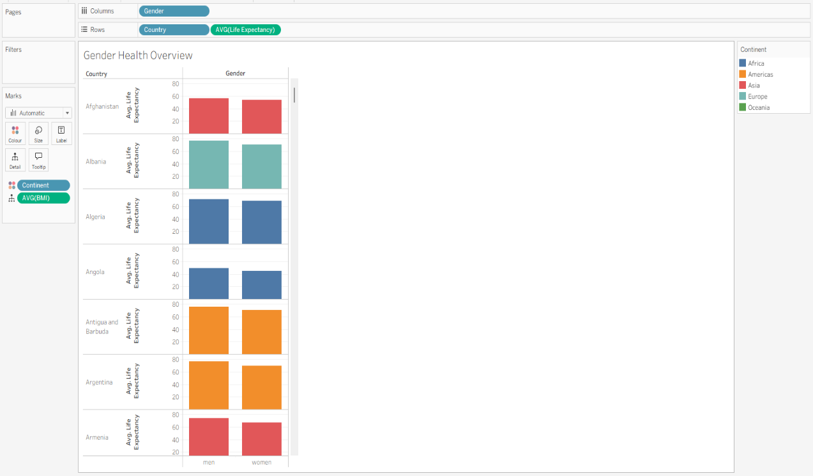
What did you find and any reflections on how the NHS could use this? | 1. Life Expectancy as a Core Health Outcome  - Countries and regions with high BMI, Blood Pressure, and high Cholesterol tend to show lower or stagnating improvements in Life Expectancy.  - If this reflects real-world global trends, it suggests a lifestyle-disease-driven strain emerging — something the NHS is already experiencing.  2. Chronic Disease Signals Align With NHS Burden  - Hypertension (Blood Pressure), Obesity (BMI), and Cholesterol — exactly the areas consuming increasing NHS resources.  - Tracking how these metrics correlate with cancer and life expectancy globally could help NHS benchmark its own prevention strategies against international patterns.  3. Population Growth + Health Risk = Future Pressure  - Countries with fast population growth and declining health metrics could indicate future migration-related health needs.  - NHS services might need to prepare for changes in patient demographics, particularly in urban centres with multinational populations.  4. Gender-Specific Trends  - The dataset includes gendered health data, which could identify whether health risks materialise differently for men and women.  - For NHS strategy, this could influence targeted screening programs (e.g., male-focused heart health, female-focused metabolic risk focus).

Day 3: Task 1

Please complete Lab 1 ‘Get Data in Power Bi Desktop’. Once complete, paste a print screen below and in the collaboration board.

“Teaching is the best way to learn, so please listen out for support requests from the class and we’ll work through the challenges together”

Paste your completed lab here | 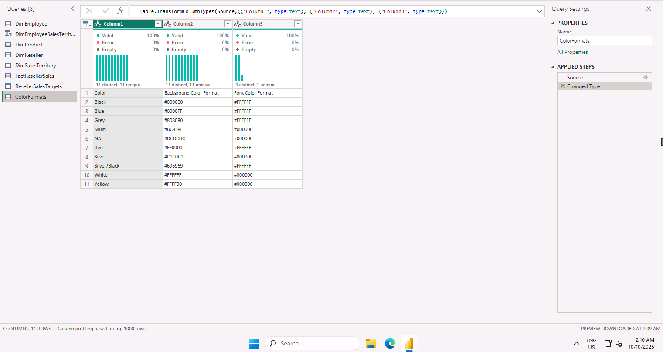

Day 3: Task 2

Please complete Lab 2 ‘Load Transformed Data in Power BI Desktop’. Once complete, paste a print screen below and in the collaboration board.

“Teaching is the best way to learn, so please listen out for support requests from the class and we’ll work through the challenges together”

Paste your completed lab here | 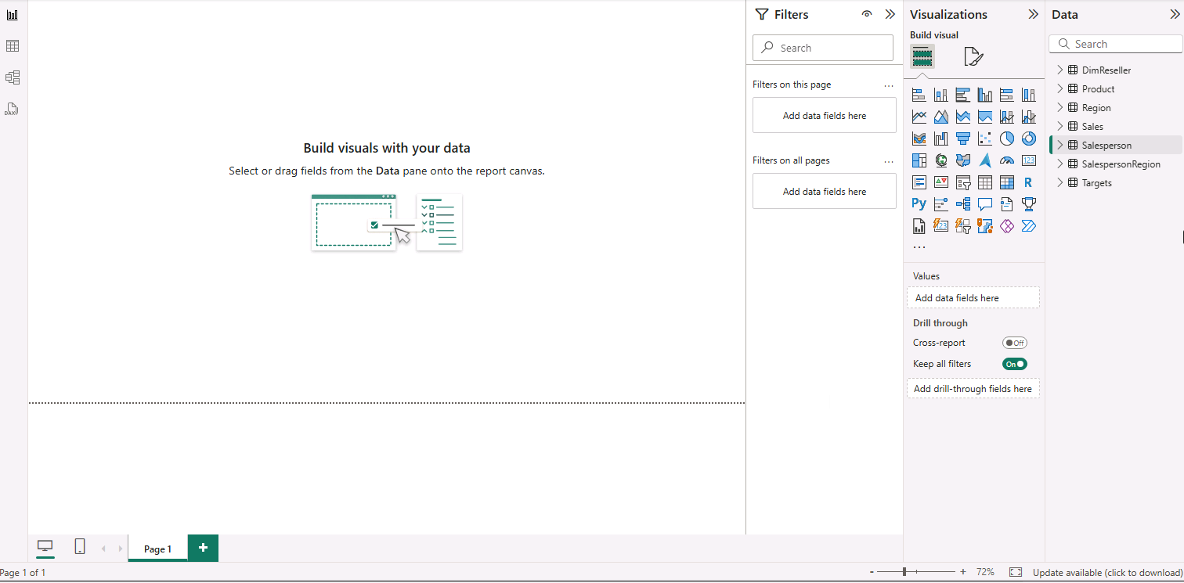

Day 4: Task 1

Please complete Lab 6 ‘Design a Report in Power BI Desktop’. Once complete, paste a print screen below and in the collaboration board.

“Teaching is the best way to learn, so please listen out for support requests from the class and we’ll work through the challenges together”

Paste your completed lab here | 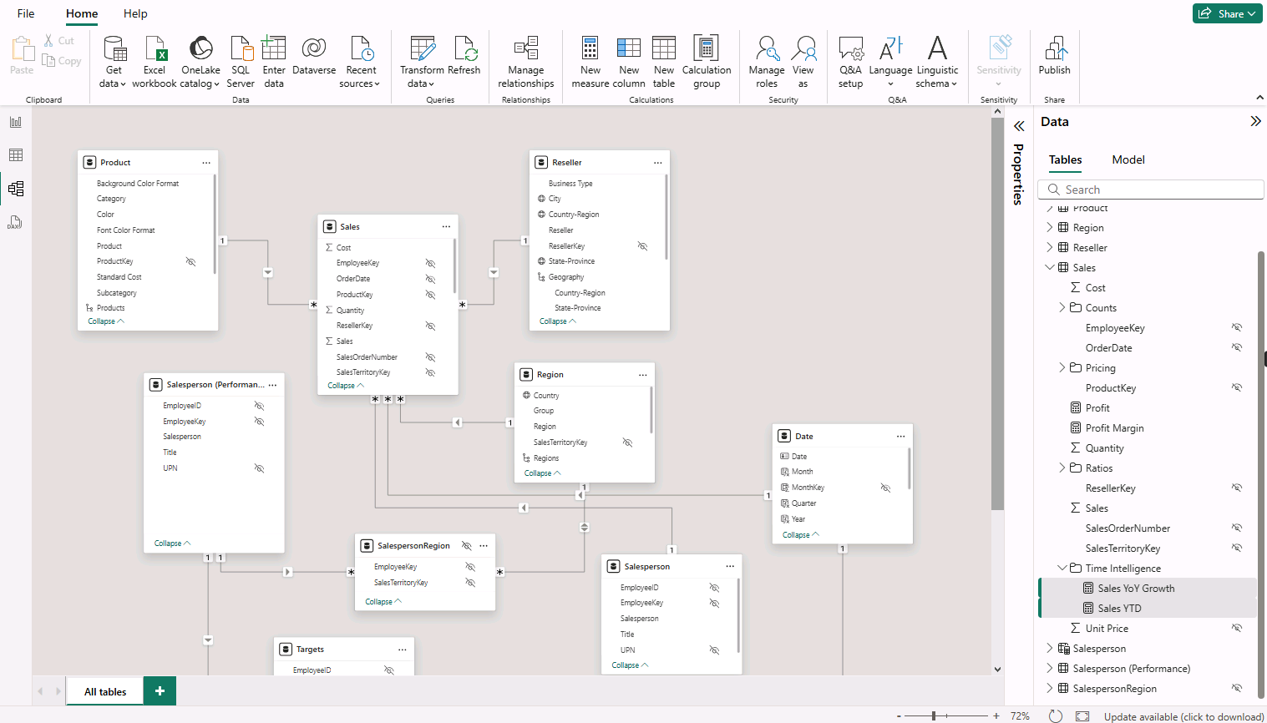

Day 4: Task 2

Please complete Lab 9 ‘Create a Power BI Dashboard’. Once complete, paste a print screen below and in the collaboration board.

“Teaching is the best way to learn, so please listen out for support requests from the class and we’ll work through the challenges together”

Paste your completed lab here | 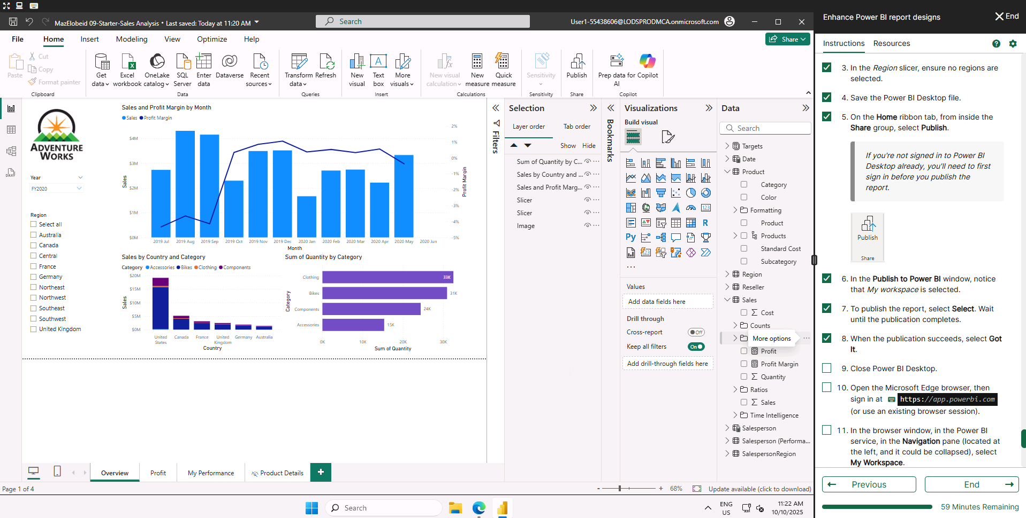

Course Notes

It is recommended to take notes from the course, use the space below to do so, or use the revision guide shared with the class:

Additional Information

We have included a range of additional links to further resources and information that you may find useful, these can be found within your revision guide.

END OF WORKBOOK

Please check through your work thoroughly before submitting and update the table of contents if required.

Please send your completed work booklet to your trainer.

